產品說明（Product Description）

本項裝飾，收藏性的產品乃從BREN MK2型機關槍的套件（在原產地屬於非管制品），依照（86）台內警字第8670683號行政函令所公告的內容，對其所指的『主要組成零件』的加工，改造，與破壞而得。以下將針對相關的主要組成零件，逐項解釋我們的作法：
This product is made from modified Bren Mk2 machine parts kit (which is not regulated in the country of origin. The modification is based on the Taiwanese Interior Department police document #8670683. It describes the requirements of modifying or destroying “major components” of firearms. We are going to explain the conformation process the manufacturer took to make the importation legal.

槍身（Receiver）

槍身在原產地屬於管制品，而本套件在進口時並不包含真正的槍身。為了美觀起見，本公司會在台灣生產假的金屬槍身。這個假槍身，除了把槍管與槍托結合在一起以外，將並不具備正常槍身的功能。
Receiver is regulated in the country of origin and this product does not include a functional receiver. For the final production, we will manufacture a dummy receiver in Taiwan to assembly this modified parts kit into a decorative dummy gun.

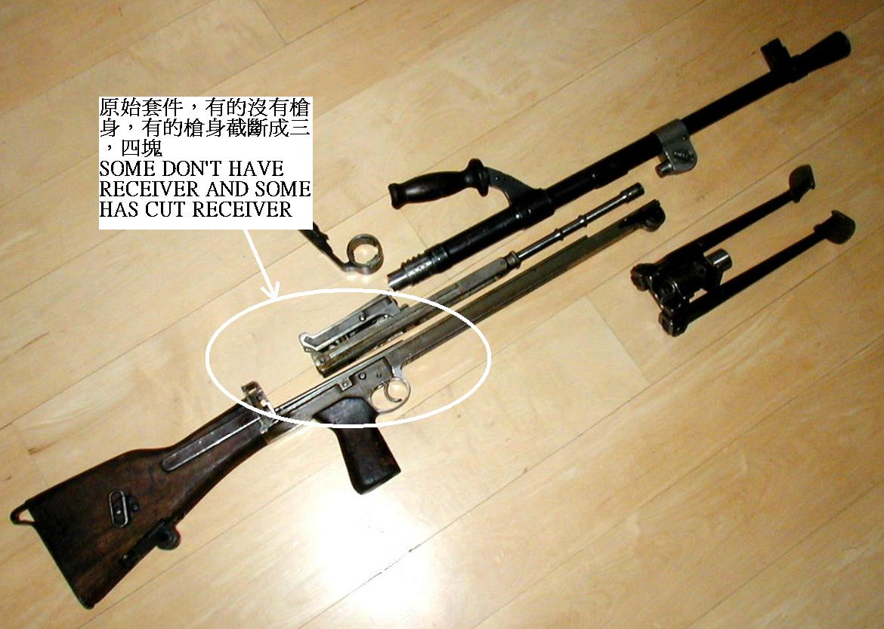
槍管（Barrel）

為了使槍管失去正常功能，生產商將採兩種步驟：
To destroy the normal function of the barrel, the manufacture will take the following 2 steps:

1. 槍膛將以同樣口徑的彈頭從前後兩方用力塞死，然後再以熔鉛封口
Plugged from both the breech and the muzzle end with the same caliber bullets, hammer them down and then seal them with molten lead.

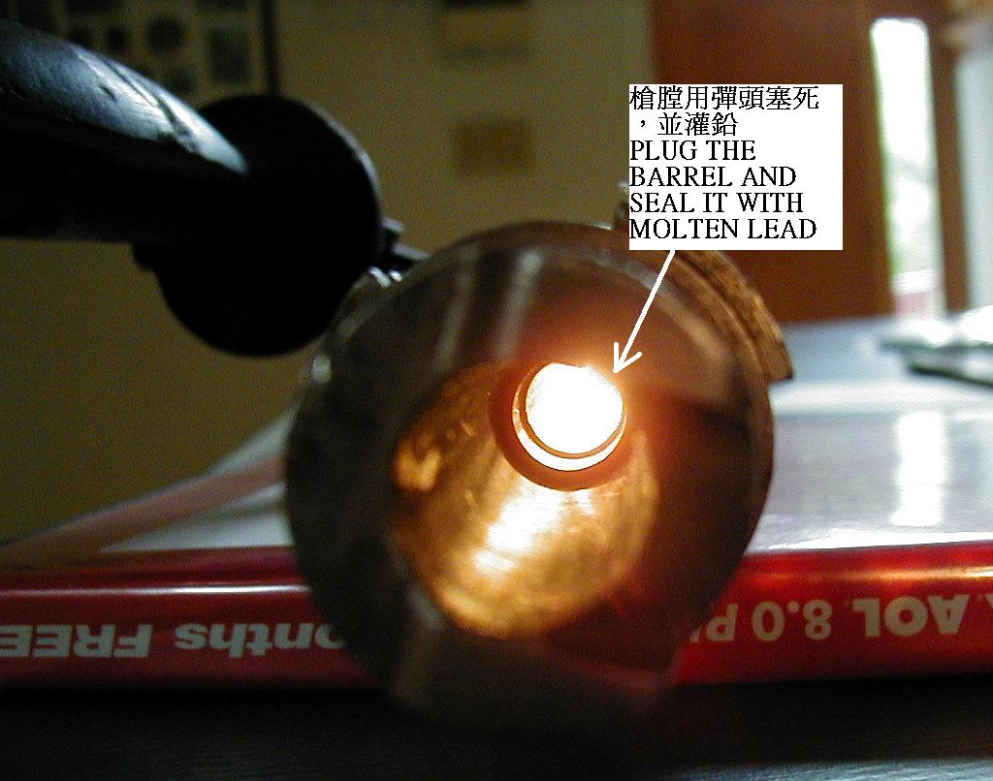

2. 將從槍管外部鑽孔直通彈膛前方，孔徑至少是5公釐。
Drill all the way into the forward of the chamber. The hole will be at least 5mm.
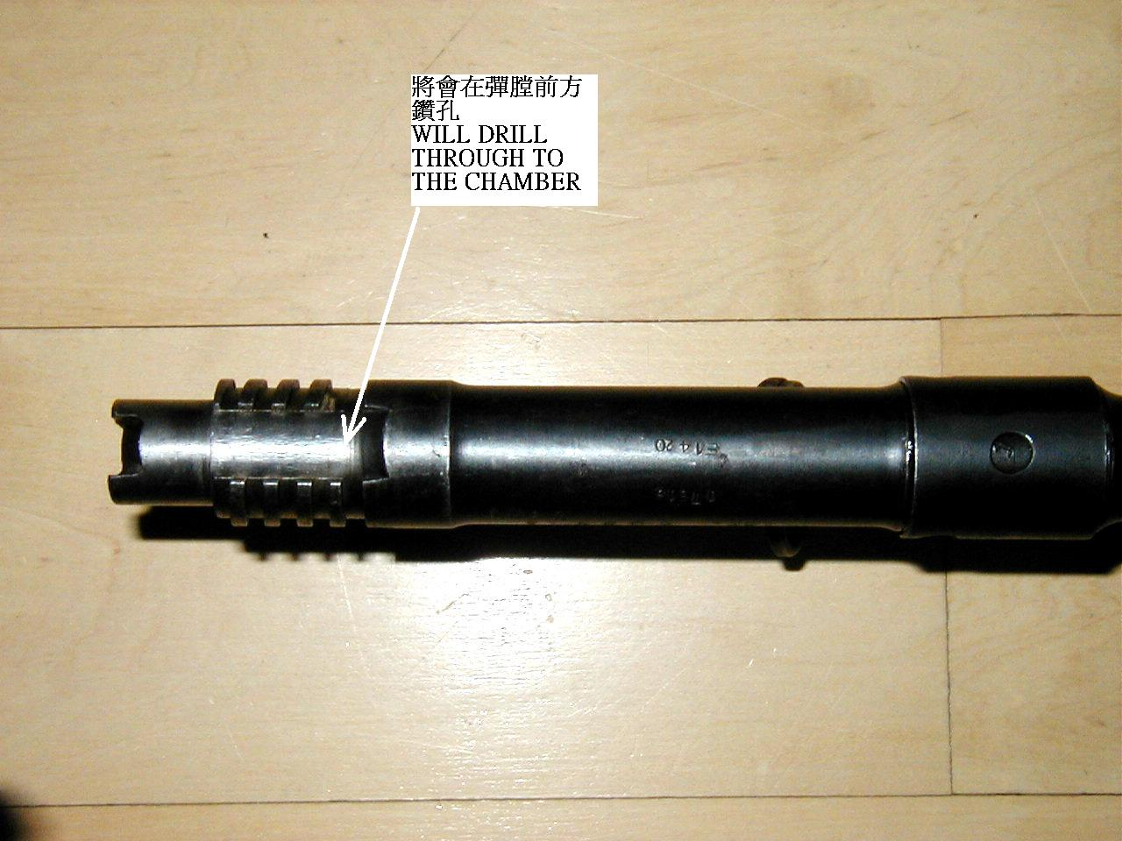

撞針（Firing pin）

生產商將會把撞針截斷，使他的長度遠短於正常長度，因而不能敲擊底火。
The manufacture will break the firing pin to make it far shorter than the regular one. This will prevent the possibility of reaching the primer.

槍閂（Bolt assembly）

生產商將從槍閂頭，撞針孔處鑽洞，使他不能承受正常擊發的工作壓力，孔徑至少是5公釐。
The manufacture will drill hole on the bolt face that is centered at the original firing pin hole. This much larger hole will make the bolt impossible to withstand normal operating pressure. The hole will be at least 5mm.

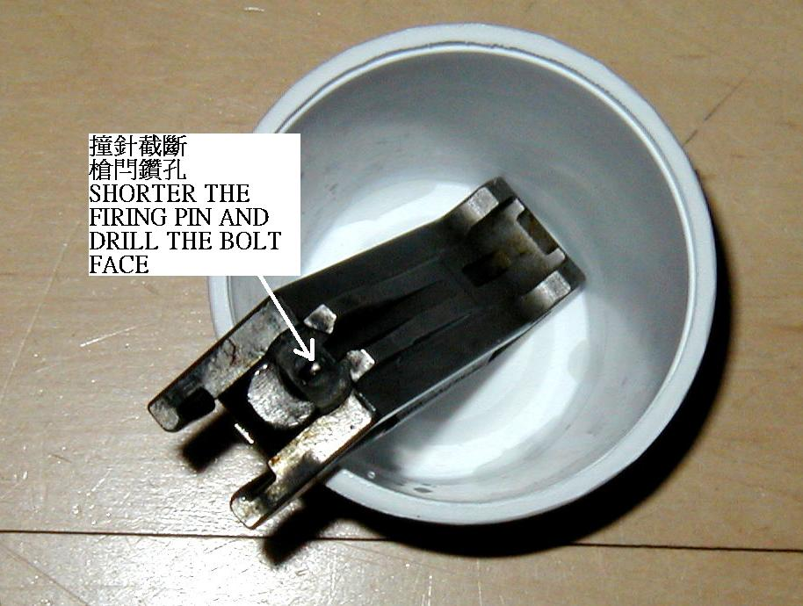

扳機（Trigger assembly）

本產品的原始設計乃採正常開放式槍閂的工作原理，停火時，槍閂靠阻鐵抵住。所以阻鐵組件拿掉便可使得扳機完全失去正常作用。生產商將會妥善處理掉這零件。
The original design of the ZB26 has a open bolt system which uses a sear to stop the falling of the bolt while not firing. This sear assembly will be taken out and never knowingly get imported.

